Newsflash
Reading, 15/09/2021

EMBARGOED UNTIL 08:00 CET, 16/09/2021

Copernicus: Southern Hemisphere ozone hole surpasses size of Antarctica
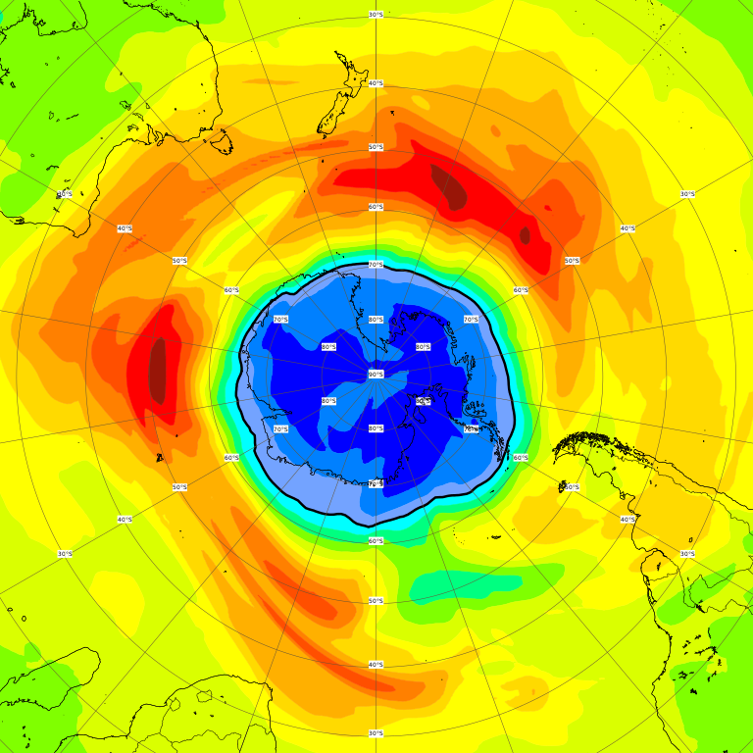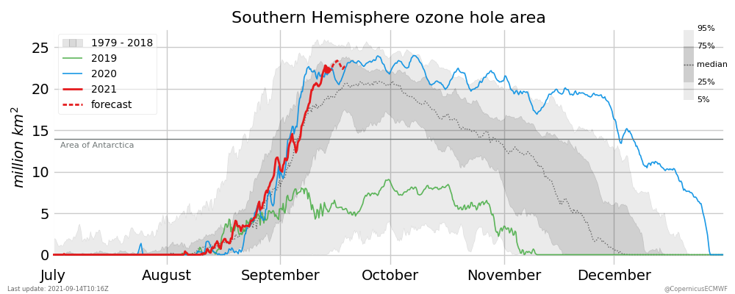
Left: CAMS ozone forecasts for Sept 14th show low values (below 220 Dobson Units) covering nearly the whole Antarctic continent. Right: CAMS forecasts for the Southern Hemisphere ozone hole area in million km² on September 14th show that this year ozone hole was close to the median of the dataset and now becomes one of the larger ones. Credit: Copernicus Atmosphere Monitoring Service/ECMWF

The Copernicus Atmosphere Monitoring Service is having a close eye on the Antarctic region to monitor the development of this year´s ozone hole over the South Pole, which has now reached an extent larger than Antarctica. After a pretty standard start, the 2021 ozone hole has considerably grown in the last week and is now larger than 75 % of ozone holes at that stage in the season since 1979.
Scientists from the Copernicus Atmosphere Monitoring Service (CAMS) have been closely monitoring the development of this year´s Antarctic ozone hole. On the International Day for the Preservation of the Ozone Layer, CAMS is giving a first status update on the stratospheric hole that appears every year during Austral spring, and the ozone layer that protects the Earth from the harmful properties of sunrays. CAMS is implemented by the European Centre for Medium-Range Weather Forecasts on behalf of the European Commission with funding from the EU.
Vincent-Henri Peuch, Director of the Copernicus Atmosphere Monitoring Service, comments: “This year, the ozone hole developed as expected at the start of the season. It seems pretty similar to last year's, which also wasn't really exceptional in September, but then turned into one of the longest-lasting ozone holes in our data record later in the season. Now our forecasts show that this year´s hole has evolved into a rather larger than usual one. The vortex is quite stable and the stratospheric temperatures are even lower than last year. We are looking at a quite big and potentially also deep ozone hole.”
CAMS’ operational monitoring of the ozone layer is using computer modelling in combination with satellite observations in a similar way to weather forecasts in order to provide a comprehensive three-dimensional picture of the state of the ozone hole. For that, CAMS effectively combines different pieces of available information. One part of the analysis consists of observations of the total column of ozone from measurements in the ultraviolet-visible part of the solar spectrum. These observations are of very high quality but are not available in the region that is still located in the polar night. A different set of observations is included, which provide crucial information about the vertical structure of the ozone layer, but has limited horizontal coverage. By combining altogether five different sources and bringing them together using its sophisticated numerical model, CAMS can provide a detailed picture of the ozone distribution with consistent total column, profile and dynamics.
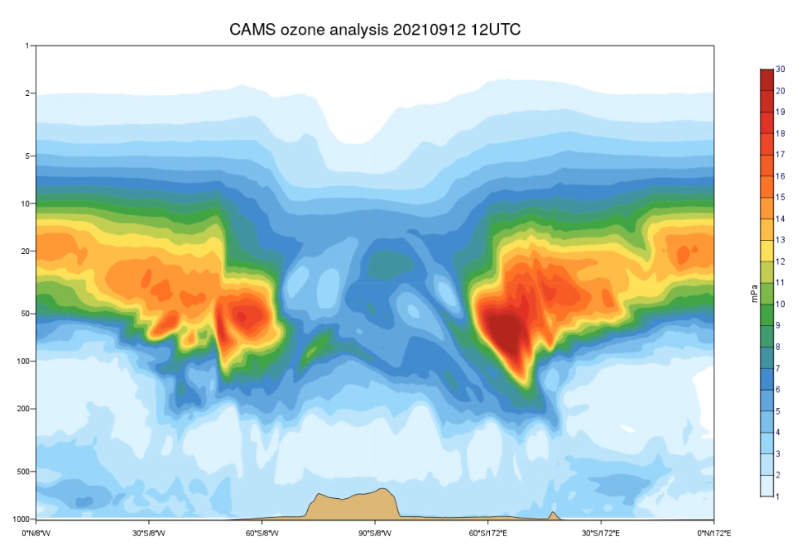
Vertical cross section of amount of ozone in mPa in the atmosphere in the Southern Hemisphere. The still of the animation on Sept 12th 2021 shows how the ozone hole develops from the edges to the middle, as sunlight starts chemical reactions depleting ozone. Credit: Copernicus Atmosphere Monitoring Service/ECMWF

As an operational programme, CAMS continually monitors the quality of its outputs against observations for the benefit of its users. Regarding its ozone forecasts, CAMS checks its system performance against “ground truth” measurements by ozone sondes that are launched in the Antarctic region by a number of international institutions. This quality monitoring effort is also an important input to the continued development of the system that is run at ECMWF.

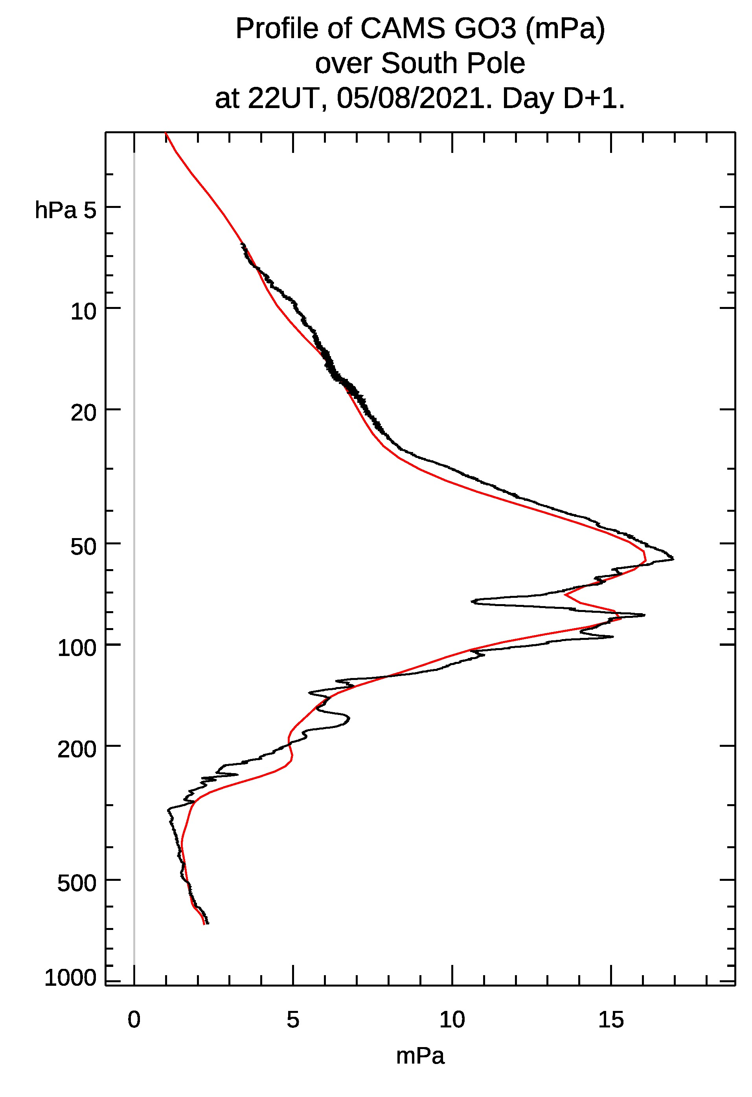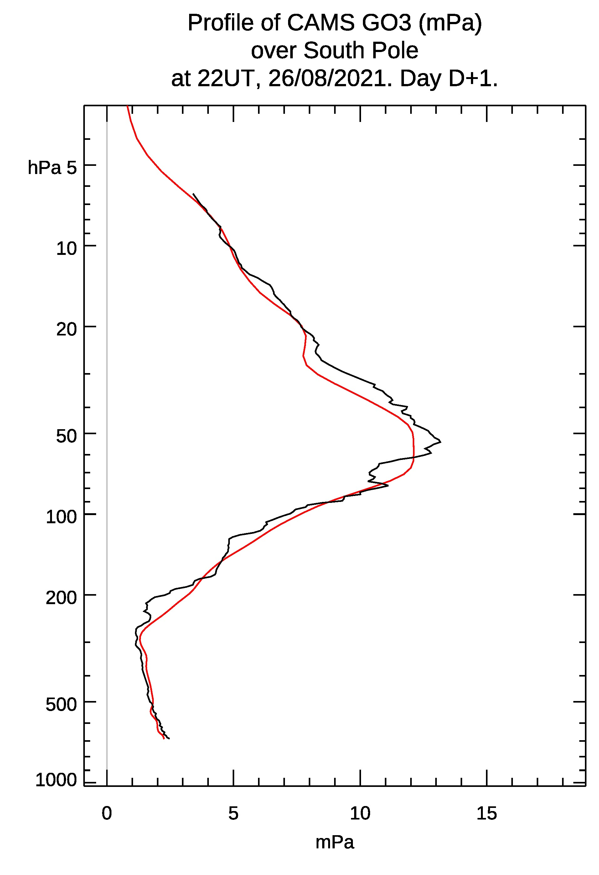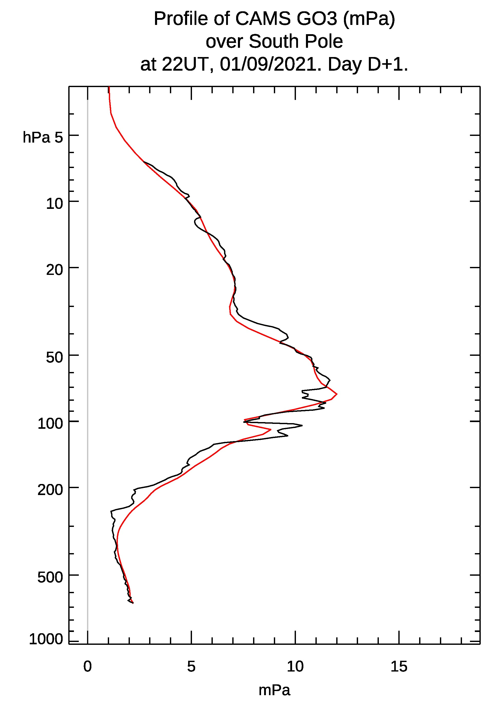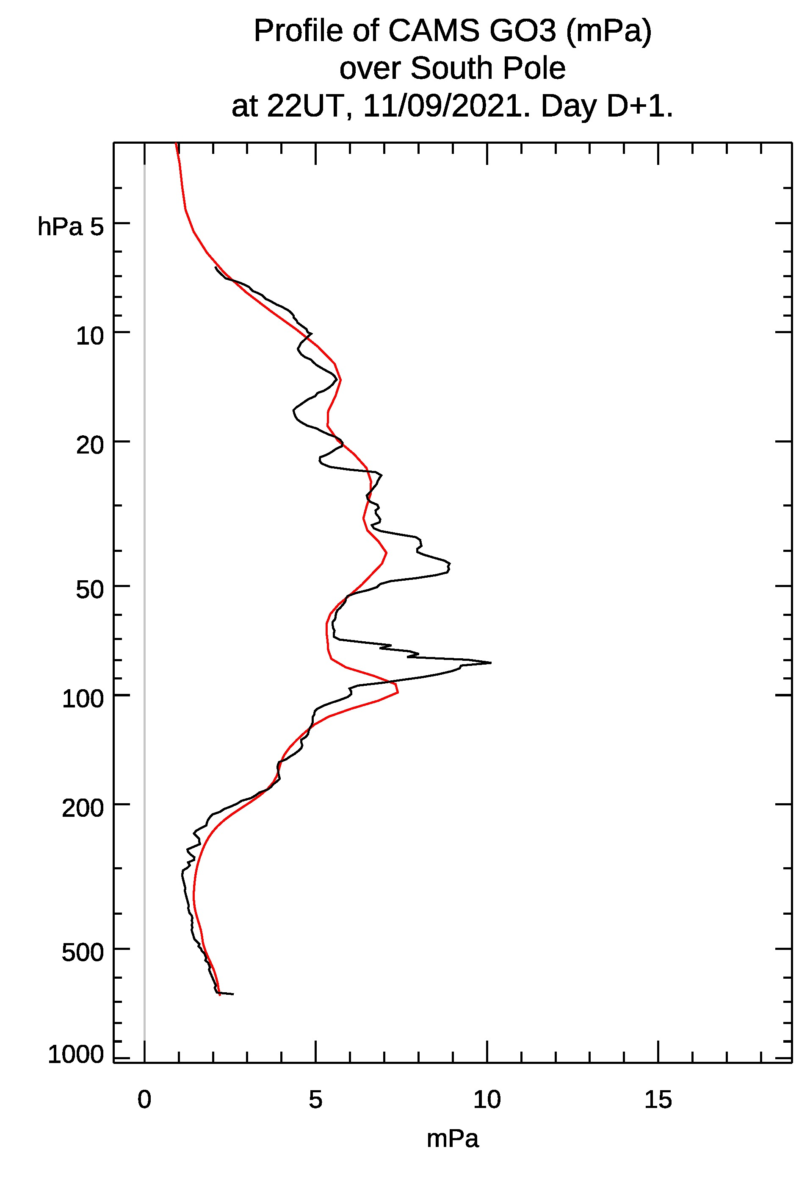
CAMS forecasts (red) of ozone values in mPa over the South Pole on 5th Aug, 26th Aug, 1st Sept and 11th Sept 2021(left to right) in comparison to the actual fully independent recorded values provided by NOAA sondes (black) show the accuracy of the CAMS forecasts. Credits: Copernicus Atmosphere Monitoring Service/ECMWF and National Oceanic and Atmospheric Administration (USA)

During the Southern Hemisphere spring season from August to October, the ozone hole forms annually over the Antarctic, reaching a maximum between mid-September and mid-October. When temperatures high up in the stratosphere start to rise in late Southern Hemisphere spring, ozone depletion slows, the polar vortex weakens and finally breaks down, and by December, ozone levels usually return to normal.

The International Day for the Preservation of the Ozone Layer was created by the United Nations to commemorate the signing of the Montreal Protocol in 1987 by 196 states and the EU, in which the main ozone-depleting chemicals were banned.

Since the ban on halocarbons, the ozone layer has shown signs of recovery, but it is a slow process and it will take until the 2060s or 2070s to see a complete phasing out of the ozone depleting substances. It is essential to maintain monitoring efforts in order to ensure that the Montreal protocol keeps being enforced.

More information on this year’s ozone hole can be found here: https://atmosphere.copernicus.eu/monitoring-ozone-healthier-world-nf

More information on the current status of the ozone hole and animations are available on the CAMS monitoring website at:
https://atmosphere.copernicus.eu/monitoring-ozone-layer

-Ends-

Notes to Editors:

Copernicus is a component of the European Union’s space programme, with funding by the EU, and is its flagship Earth observation programme, which operates through six thematic services: Atmosphere, Marine, Land, Climate Change, Security and Emergency. It delivers freely accessible operational data and services providing users with reliable and up-to-date information related to our planet and its environment. The programme is coordinated and managed by the European Commission and implemented in partnership with the Member States, the European Space Agency (ESA), the European Organisation for the Exploitation of Meteorological Satellites (EUMETSAT), the European Centre for Medium-Range Weather Forecasts (ECMWF), EU Agencies and Mercator Océan, amongst others.

ECMWF operates two services from the EU’s Copernicus Earth observation programme: the Copernicus Atmosphere Monitoring Service (CAMS) and the Copernicus Climate Change Service (C3S). They also contribute to the Copernicus Emergency Management Service (CEMS), which is implemented by the EU Joint Research Council (JRC). The European Centre for Medium-Range Weather Forecasts (ECMWF) is an independent intergovernmental organisation supported by 34 states. It is both a research institute and a 24/7 operational service, producing and disseminating numerical weather predictions to its Member States. This data is fully available to the national meteorological services in the Member States. The supercomputer facility (and associated data archive) at ECMWF is one of the largest of its type in Europe and Member States can use 25% of its capacity for their own purposes.

ECMWF is expanding its location across its Member States for some activities. In addition to an HQ in the UK and Computing Centre in Italy, new offices with a focus on activities conducted in partnership with the EU, such as Copernicus, will be located in Bonn, Germany from Summer 2021.
The Copernicus Atmosphere Monitoring Service website can be found at http://atmosphere.copernicus.eu/
The Copernicus Climate Change Service website can be found at https://climate.copernicus.eu/
More information on Copernicus: www.copernicus.eu
The ECMWF website can be found at https://www.ecmwf.int/

Twitter:
@CopernicusECMWF
@CopernicusEU
@ECMWF
#EUSpace

Media contact
Nuria Lopez

Communications | Copernicus Contracts and Press
Office of the Director General
European Centre for Medium-Range Weather Forecasts
Reading, UK | Bologna, Italy

Email: copernicus-press@ecmwf.int
Phone: +44 (0)118 949 9778
Mobile: +44 (0)7392 277 523

